**Cloud instance information:**

* Intel Haswell platform
* 1 CPU
* 3.75 GB memory
* Ubuntu OS
* 10 GB HDD

**Task 1 -** 15 minutes of performance testing was performed with user behaviours like **Login, Browsing, and Purchasing** as the simulated actions.

* 4 users only actions were browsing
* 4 users log in first and then start browsing
* 2 users log in first and purchase an item

|  |  |  |  |
| --- | --- | --- | --- |
| **HTTP Request** | **Average** | **90% Line** | **95% Line** |
| Browse/jpetstore/actions/Catalog.action-1 | 66 | 63 | 66 |
| Browse/jpetstore/actions/Catalog.action-2 | 70 | 63 | 69 |
| Browse/jpetstore/actions/Catalog.action-3 | 68 | 63 | 67 |
| Login/jpetstore/actions/Account.action-1 | 67 | 62 | 66 |
| Login/jpetstore/actions/Account.action-2 | 133 | 126 | 175 |
| Login/jpetstore/actions/Catalog.action-3 | 66 | 62 | 65 |
| Purchasing/jpetstore/actions/Cart.action-1 | 74 | 69 | 74 |
| Purchasing/jpetstore/actions/Order.action-2 | 69 | 63 | 77 |
| Purchasing/jpetstore/actions/Order.action-3 | 68 | 63 | 97 |
| Purchasing/jpetstore/actions/Order.action-4 | 67 | 63 | 67 |
| TOTAL | 76 | 104 | 120 |

**Throughput:** 130.9/sec

**CPU usage** - CPU utilization at idle (no test performed) was at a minimum of 0. At the start of the performance testing, CPU usage went very high with maximum usage of 94 and flatlined halfway through the test, median maximum CPU usage of 84.

**IDLE START MEDIAN**

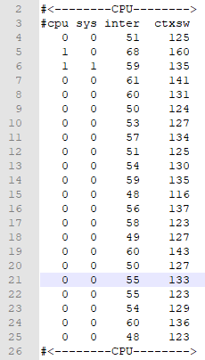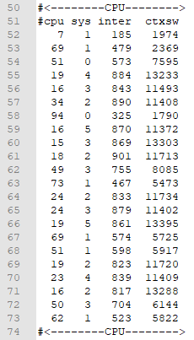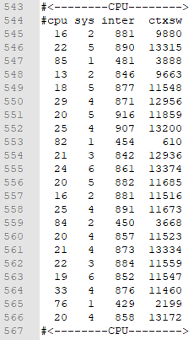

**Response Time Graph**

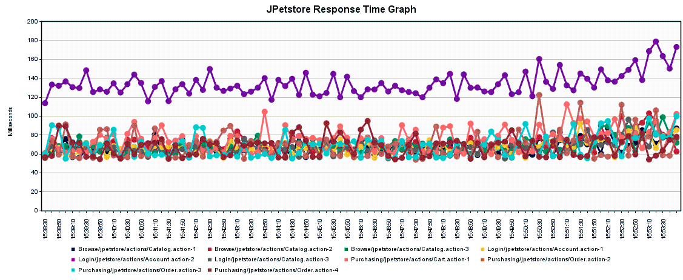

**Task 2**

**100 User Test -** 3 rounds of 100 user performance testing produces pretty consistent results with some acceptable deviations in the average and 95% line.

**Round 1**

|  |  |  |  |
| --- | --- | --- | --- |
| **HTTP Request** | **Average** | **90% Line** | **95% Line** |
| Browse/jpetstore/actions/Catalog.action-1 | 120 | 155 | 166 |
| Browse/jpetstore/actions/Catalog.action-2 | 55 | 62 | 63 |
| Browse/jpetstore/actions/Catalog.action-3 | 55 | 61 | 62 |
| TOTAL | 77 | 121 | 141 |

**Round 2**

|  |  |  |  |
| --- | --- | --- | --- |
| **HTTP Request** | **Average** | **90% Line** | **95% Line** |
| Browse/jpetstore/actions/Catalog.action-1 | 118 | 145 | 161 |
| Browse/jpetstore/actions/Catalog.action-2 | 56 | 63 | 64 |
| Browse/jpetstore/actions/Catalog.action-3 | 56 | 63 | 64 |
| TOTAL | 77 | 122 | 128 |

**Round 3**

|  |  |  |  |
| --- | --- | --- | --- |
| **HTTP Request** | **Average** | **90% Line** | **95% Line** |
| Browse/jpetstore/actions/Catalog.action-1 | 111 | 126 | 127 |
| Browse/jpetstore/actions/Catalog.action-2 | 56 | 63 | 63 |
| Browse/jpetstore/actions/Catalog.action-3 | 56 | 63 | 64 |
| TOTAL | 74 | 120 | 123 |

**1500 User Test -** Similarly 3 rounds of 1500 performance user test produces consistent results with some acceptable deviations in the average and 95% line.

**Round 1**

|  |  |  |  |
| --- | --- | --- | --- |
| **HTTP Request** | **Average** | **90% Line** | **95% Line** |
| Browse/jpetstore/actions/Catalog.action-1 | 575 | 1112 | 1556 |
| Browse/jpetstore/actions/Catalog.action-2 | 511 | 798 | 1086 |
| Browse/jpetstore/actions/Catalog.action-3 | 482 | 704 | 953 |
| TOTAL | 523 | 922 | 1137 |

**Round 2**

|  |  |  |  |
| --- | --- | --- | --- |
| **HTTP Request** | **Average** | **90% Line** | **95% Line** |
| Browse/jpetstore/actions/Catalog.action-1 | 510 | 981 | 1108 |
| Browse/jpetstore/actions/Catalog.action-2 | 518 | 944 | 1085 |
| Browse/jpetstore/actions/Catalog.action-3 | 462 | 689 | 912 |
| TOTAL | 497 | 909 | 1076 |

**Round 3**

|  |  |  |  |
| --- | --- | --- | --- |
| **HTTP Request** | **Average** | **90% Line** | **95% Line** |
| Browse/jpetstore/actions/Catalog.action-1 | 505 | 972 | 1084 |
| Browse/jpetstore/actions/Catalog.action-2 | 526 | 1010 | 1107 |
| Browse/jpetstore/actions/Catalog.action-3 | 450 | 750 | 1048 |
| TOTAL | 494 | 958 | 1096 |

**100 to 1500 increment User Test**

|  |  |  |  |
| --- | --- | --- | --- |
| **Users** | **Average** | **Users** | **Average** |
| 100 | 75 | 900 | 334 |
| 200 | 76 | 1000 | 362 |
| 300 | 87 | 1100 | 409 |
| 400 | 90 | 1200 | 419 |
| 500 | 107 | 1300 | 433 |
| 600 | 133 | 1400 | 442 |
| 700 | 255 | 1500 | 496 |
| 800 | 324 |  |  |

**Average Response Time Plot Graph**

